P
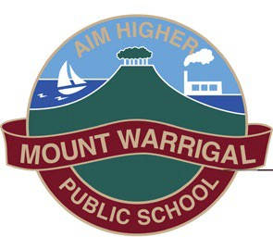
Mount Warrigal Public School
“Aim Higher”
2 Hogarth Ave, Mount Warrigal NSW 2528 Ph: 4296 6266
www.mtwarrigal-p.schools.nsw.edu.au mtwarrigal-p.school@det.nsw.edu.au Principal: Ms Jodi Niedermayer

Special Religious Education and Special Education in Ethics Participation Letter
A feature of the public education system in NSW is the opportunity to provide time in class for education in ethics, faith and morality from a religious or non-religious perspective at the choice of parents.
The school website https://mtwarrigal-p.schools.nsw.gov.au/ provides information on these options to support parent/carer choice.
A parent/carer may at any time notify the school in writing that they wish to change their decision. Students will continue the same arrangement as the previous year, unless a parent/carer has requested a change in writing.
For more information about Special Religious Education (SRE) and Special Education in Ethics (SEE), including the list of approved providers, please visit: https://education.nsw.gov.au/teaching-and-learning/curriculum/learning-across-the-curriculum/religion-and-ethics
If your preferred SRE or SEE option is not available please contact the approved provider. Students not attending SRE or SEE are given supervised alternative activities.
The following options are available at Mount Warrigal Public School. Please choose one.
SRE Options
□ Protestant. (This includes lessons involving bible stories, songs, activities and an activity book. This group includes Anglican, United, Baptist and Salvation Army.)
□ Bahai. (This is an interdomenational group and invites children from any religious group to join. Lessons involve music, songs, games, craft and stories.)
OR
□ Please check this box if you do not wish for your child to attend SRE. Your child will participate in alternative meaningful activities.
Student name: Year:

Signature of parent/carer: Date:

